**Trường THCS Hoàng Lê Kha** **THEME 7: MY NEIGHBORHOOD Grade 8**

Week 13 - P: 25, 26 **LESSON 3: LANGUAGE FOCUS**

Date: 29/11-04/12/2021

**Task 1. Match each verb to its past participle.**

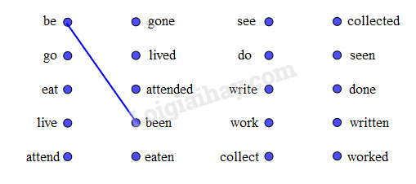

**ANSWER KEYS:**

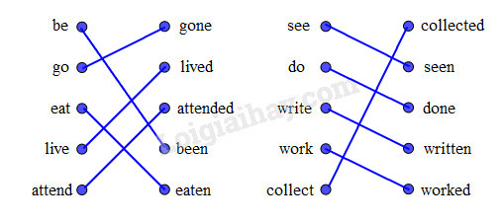

**Task 2. Complete the expressions. Use for or since.**

|  |
| --- |
| for a period of time                    since a point of time  for five months                          since Tuesday |

|  |  |
| --- | --- |
| ..... five minutes  ..... January  ..... 1990  ..... the summer | ..... three hours  ..... two weeks  ..... Friday  ..... 20 years |

**ANSWER KEYS:**

for five minutes                  for three hours

since January                     for two weeks

since 1990                          since Friday

since the summer               for 20 years

**Task 3. Complete the sentences. Use the present perfect form of the verbs in brackets.**

a. I **______** here since last week.             (live)

b. We **_______** in that restaurant for two weeks. (not eat)

c. I **______** her since yesterday.             (not see)

d. They **_______** Quang Trung School since last year.  (attend)

e. My Dad **_______** for this company for 20 years.  (work)

f. Ba **_______** stamps since 1995.   (collect)

**ANSWER KEYS:**

a. I **have lived** here since last week.

b. We **haven't eaten** in that restaurant for two weeks.

c. I **haven't seen** her since yesterday.

d. They **have attended** Quang Trung School since last year.

e. My Dad **has worked** for this company for 20 years.

f. Ba **has collected** stamps since 1995.

**Task 4. Complete the conversation. Use the correct form of the verbs in the box.**

|  |
| --- |
| **hope       be (3)       live       see        look        want** |

Ba: Hi. My name’s Ba.

Tom: Nice to meet you, Ba. I'm Tom.

Ba: Are you a newcomer here?

Tom: Yes. I (1)_______ here since last week.

Ba: I’m sure you’ll love this place.

Tom: I (2) _______ so. How long _____ you (3) _______ here?

Ba: For 15 years.

Tom: So you must know the area very well. (4)_______ there a post office near here?

Ba: Yes. There's one next to my house. Why?

Tom: Ah! I (5) ________ to send this postcard to my parents.

Ba: Let me have a look. Oh! It (6) ________ very beautiful. Where's your house?

Tom: In London. _______ you ever (7) ________ there?

Ba: Not yet. But I (8) _______ it through films and magazines. I’m going there with my father next summer.

Tom: That’s great. I hope to see you again there.

**ANSWER KEYS:**

(1) have been                             (2) hope

(3) have you lived                       (4) Is

(5) want                                     (6) looks

(7) Have you ever been              (8) saw

**Task 5. Look at the pictures. Complete the sentences. Use the words in the box. You will have to use some words more than once.**

*(Hãy nhìn tranh và hoàn thành các câu sau, sử dụng từ cho trong khung. Em sẽ phải dùng một vài từ hơn một lần.)*

|  |
| --- |
| different       expensive         cheap  modern        long                  same          large |

a) The magazine is*not as large as* the newspaper.

b) Lipton tea is*different from* Dilmah tea.

c) The red dictionary is ________ the blue dictionary.

d) The bag on the left is________ the bag on the right.

e) The toy cat is_______ the toy dog.

f) Hoa’s backpack is________ Lan's backpack.

g) The snake is_______ the rope.

h) The pocket-watch is________ the wristwatch.

i) The ruler is________ the eraser.  
**ANSWER KEYS:**

a. The magazine is **not as large as** the newspaper.

b. The English newspaper is **different from** the Vietnamese newspaper.

c. The red dictionary is **different from** the blue dictionary.

d. The bag on the left is **the same as** the bag on the right.

e. The toy cat is **not as large as** the toy dog.

f. Hoa’s backpack is **the same as** Lan’s backpack.

g. The snake is **not as long as** the rope.

h. The pocket-watch is **not as modern as** the wristwatch.

i. The ruler is not **as cheap as** the eraser.